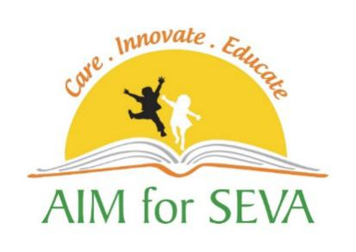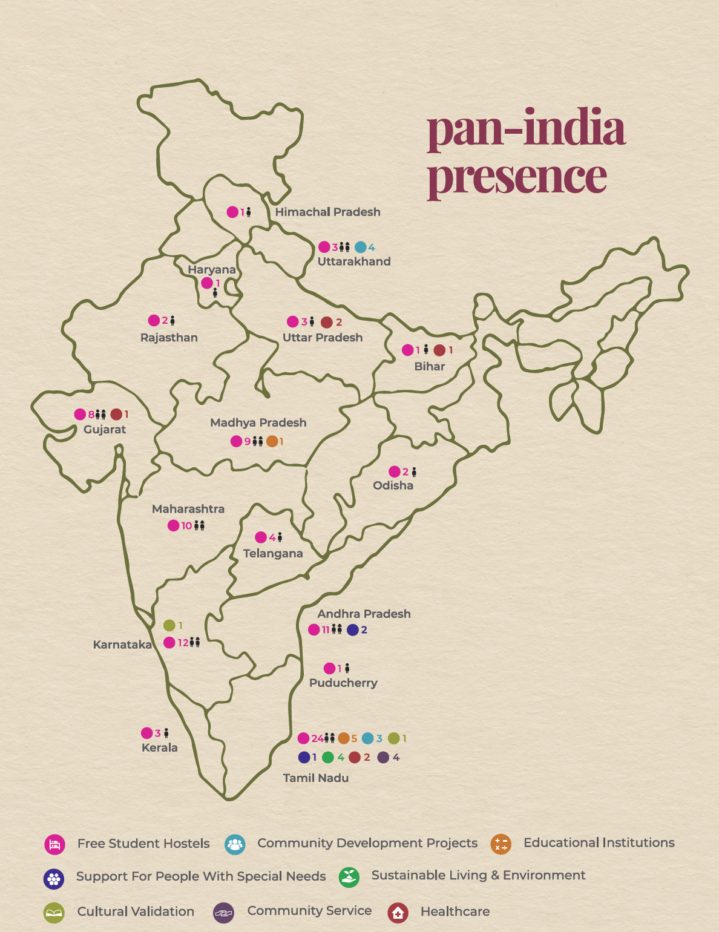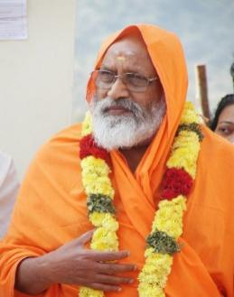

**All India Movement for Seva**

**Educating Rural India through Free Student Hostels**

##### **Feature Story: Prestigious awards to AIM for Seva**

**Nari Shakti Puraskar 2017 awarded to Ms. Sheela Balaji, Chairperson and Managing Trustee of AIM for Seva and Swami Dayananda Education Trust**

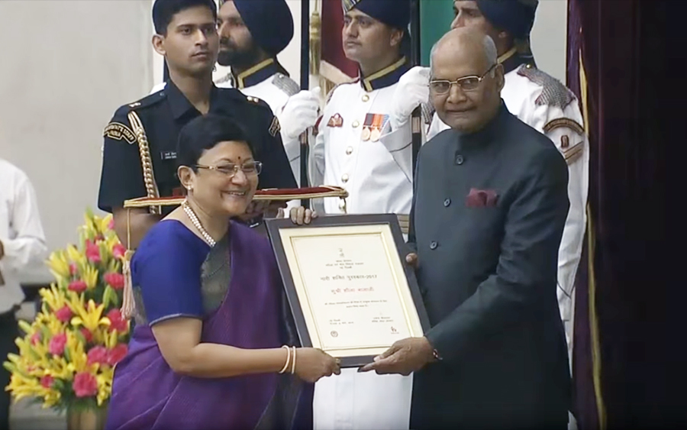

Ms. Sheela Balaji received the Nari Shakti Puraskar 2017 award for her outstanding contribution to women’s empowerment from President Ram Nath Kovind on the occasion of International Women’s Day at Rashtrapati Bhavan, New Delhi.

Ms. Balaji through 127 projects under the flagship of AIM for Seva (a pan-India NGO) and Swami Dayananda Educational Tust (an integrated community initiative) has set an example of outstanding work in rural India, providing a free of cost, value-based education, to rural and tribal children.

**AIM for Seva has 127 projects across 16 states in India.**

**Please look for a series of monthly stories from us that will inform you about this wonderful work!**

**We ask you for your contribution to this well-defined, well-deserving, and well-run program. Please donate at our website,** [**www.aimforsevabayarea.org**](http://www.aimforsevabayarea.org)**; Contact:** [**vijaykapoor@gmail.com**](mailto:vijaykapoor@gmail.com) **(650-208-9565)**

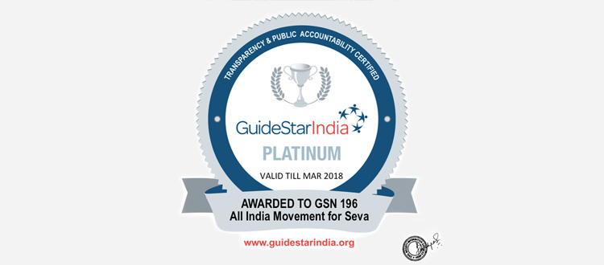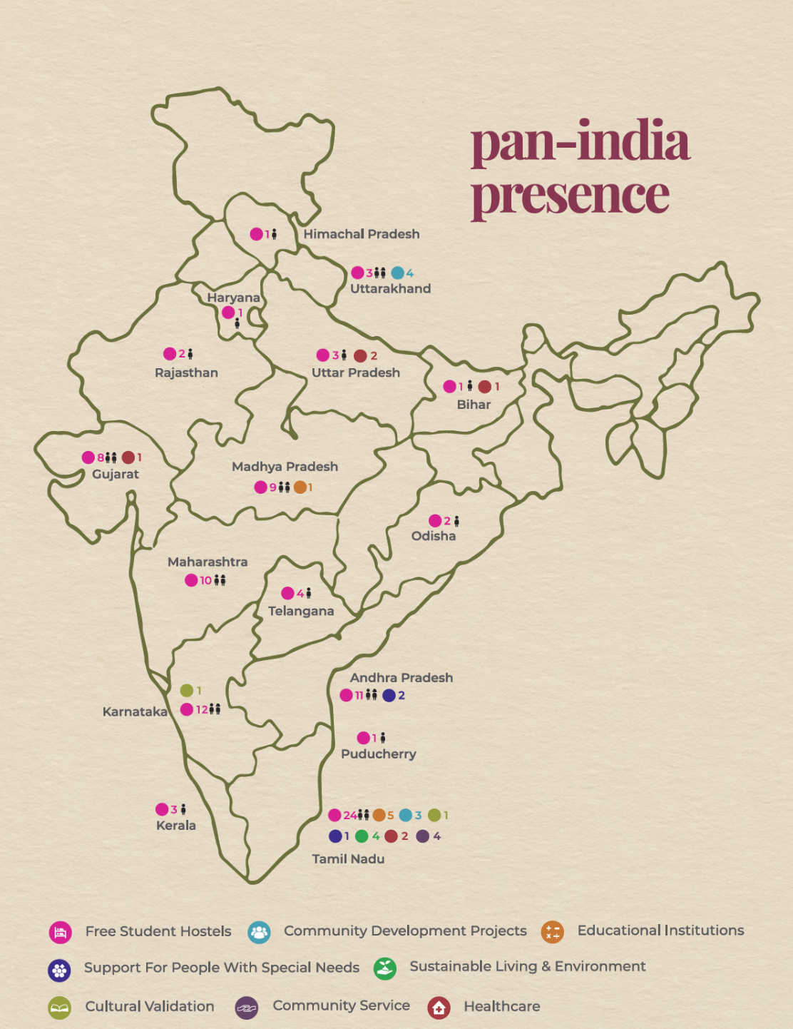https://www.youtube.com/watch?v=-XxclwTK3jU https://www.youtube.com/watch?v=-XxclwTK3jU 

**Please look for a series of monthly stories from us that will inform you about this wonderful work of AIM for Seva!**

**We ask you for your involvement and support to this well-defined, well-deserving, and well-run program.**

**For details, please visit our website,** [**www.aimforsevabayarea.org**](http://www.aimforsevabayarea.org)**; Contact:** [**vijaykapoor@gmail.com**](mailto:vijaykapoor@gmail.com) **(650-208-9565)**

AIM for Seva has qualified for “Champion Level- GuideStar India Platinum” Certification for 2017-2018.  GuideStar India’s Platinum Certification is the Champion Level Certification which indicates that comprehensive transparency, accountability and good governance procedures are adopted by AIM for Seva with exemplary **level of public disclosure.**